

Installation Guide

Workspace Setup / Deployment of Conversation Moderator



December 7, 2018

Rejoice Jebamalaidass

Loyola University Chicago

Contents

Workspace Setup 2

Clone / Download codebase from GITHUB 2

Setup Workspace 3

Running App using Android Studio 4

Running App in Local Machine 5

Building APK from Local Machine 9

Deploying APK in Google Play store 11

App Releases 16

# Workspace Setup

## Clone / Download codebase from GITHUB

GitHub URL: <https://github.com/rejoiceraja/ConvMod>

Click the Clone or Download button to view the popup window. In the popup window, click on the Download ZIP button to download codebase to local machine.

In addition, you could copy the URL or use the following URL to clone the code into local machine.

<https://github.com/rejoiceraja/ConvMod.git>

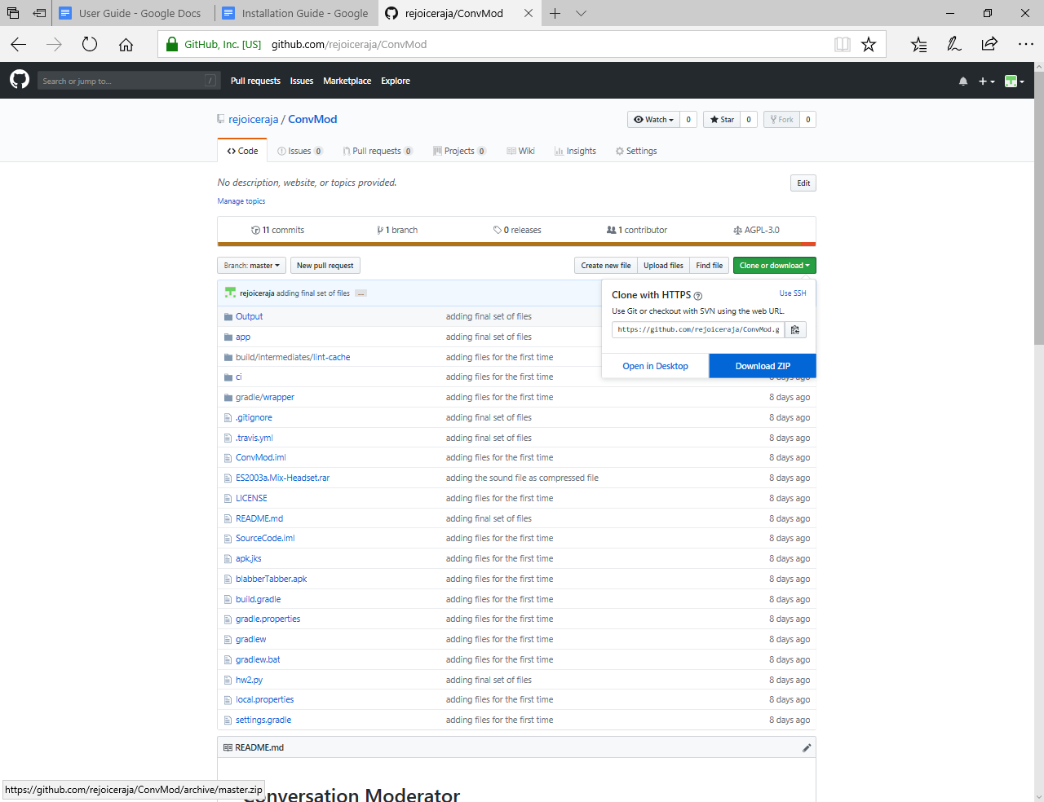

## Setup Workspace

Unzip the downloaded file into the required folder or using GIT Client, clone codebase into the GIT repository in the local machine.

After download, open Android Studio. Select Menu -> Open Project and select the downloaded project location.

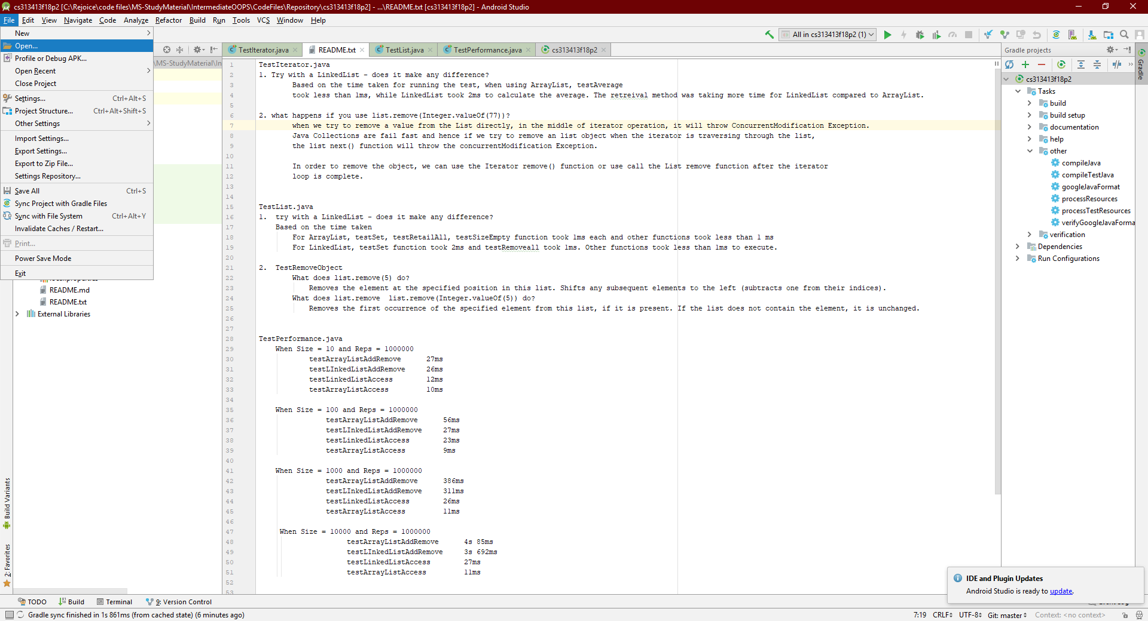

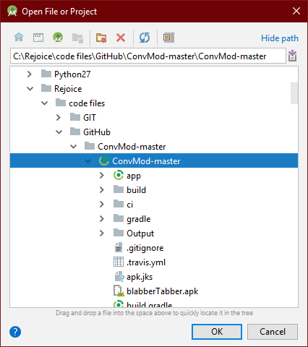

On selecting the project, Android studio will open the project in the Android perspective.

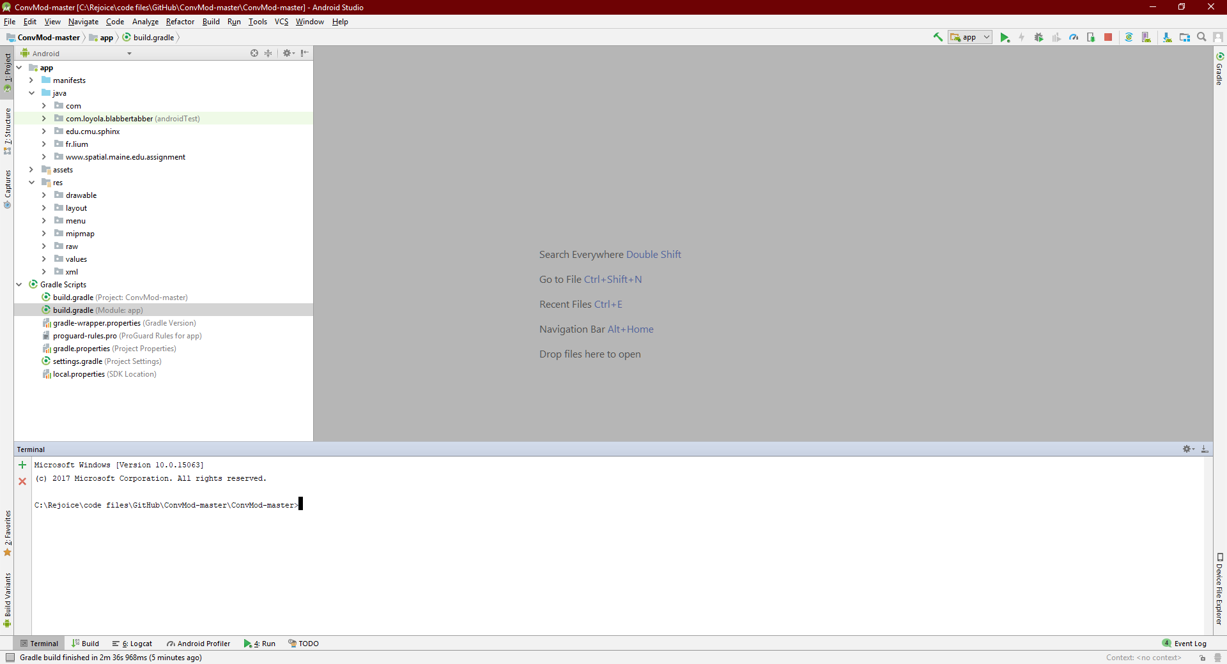

# Running App using Android Studio

Click the Green Play button on the Top menu after selecting the App from the adjacent Dropdown menu.

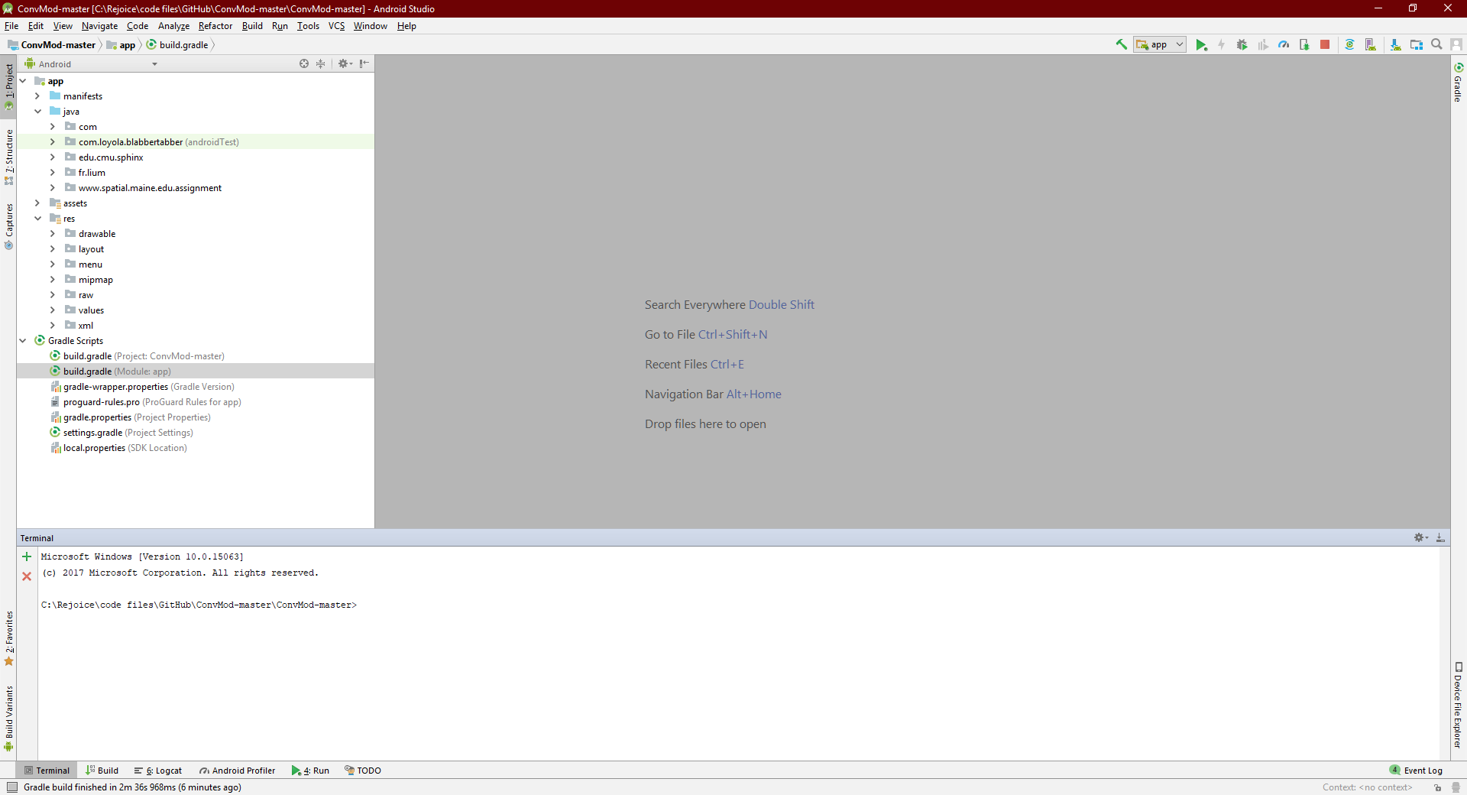

## Running App in Local Machine

On clicking the play button, Android Studio will open the window to select the deployment Target.

If you have plugged in the Android phone to your local machine, deployment window will display the connected Android phone. You can select the phone for testing directly in the phone or you can create a new virtual machine for testing the application.

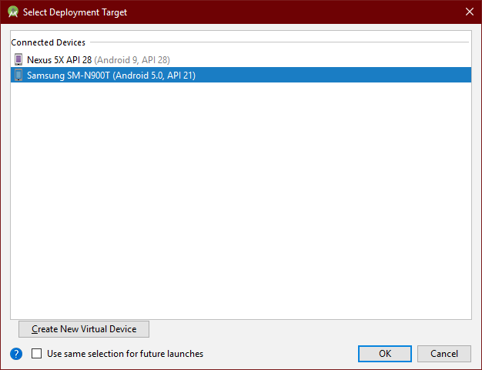

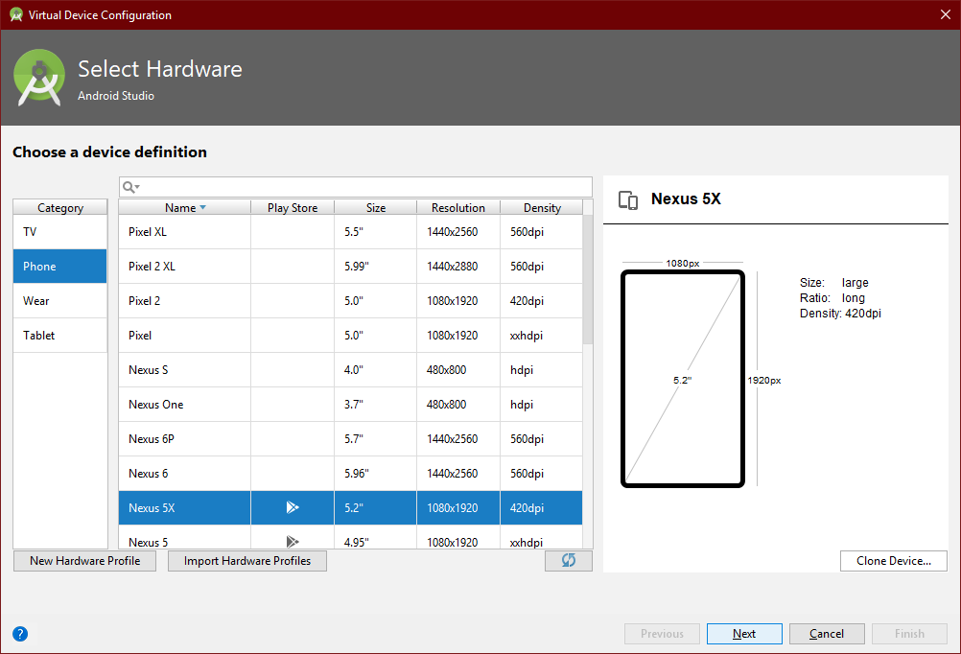

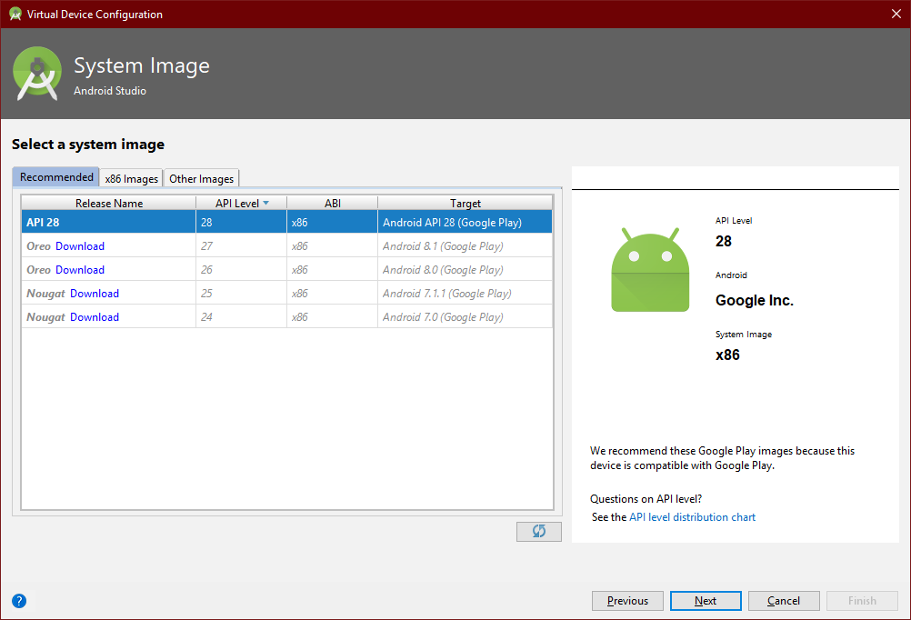

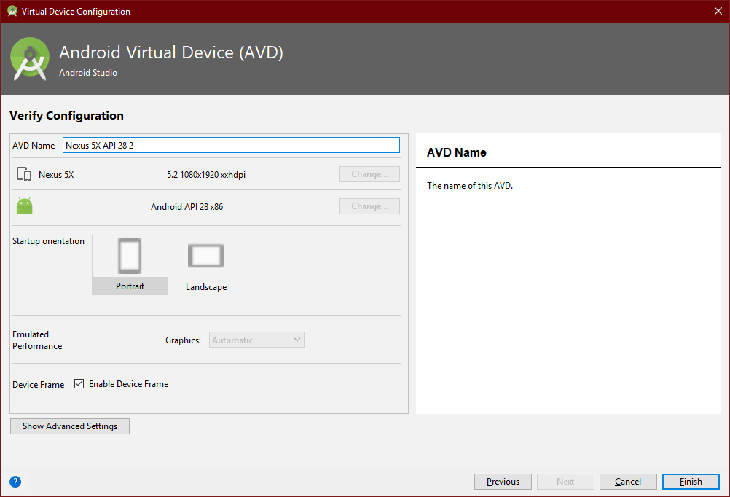

On clicking Finish button, Android Studio opens the selected Virtual Machine, builds the app using gradle build tool and deploy the APK in the virtual machine.

After deployment, the APK opens in the virtual machine like the below screenshot.

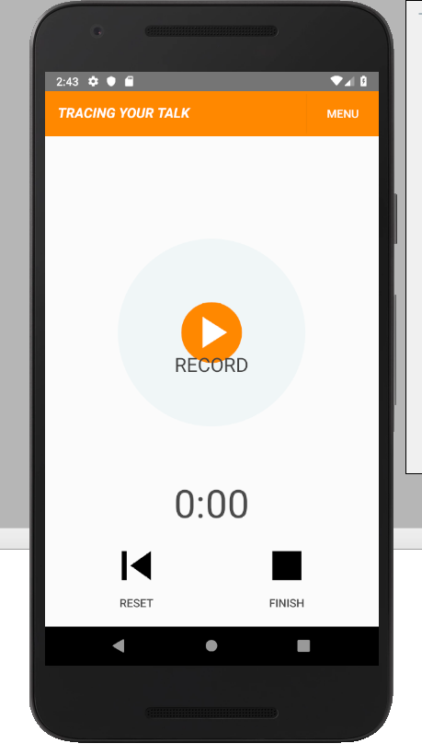

You can read the user guide to know more on how to use the app.

# Building APK from Local Machine

For building APK, select Build ->Generate Signed APK option.

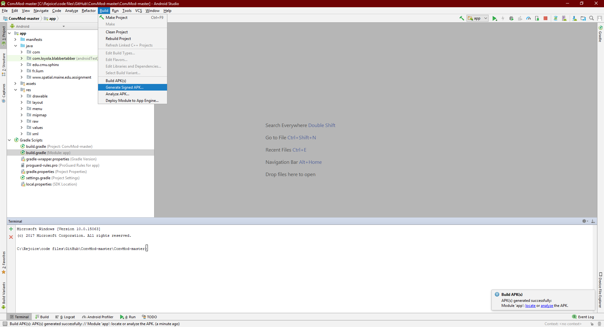

For signing the APK, you need to have a SSL Certificate added to the Java Key Store. After adding the certificate to the Java Key store, you need to add the key store path, keystore Password, Certificate Alias and certificate Password in the build window. An example is shown below.

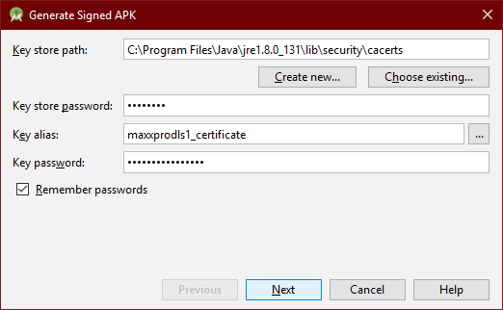

On clicking Next button, you need to specify the APK Destination folder and the APK Build type. There are two types of APK build type, Debug and Release. Also, select the V1 and V2 signature version.

After providing the required details, click Finish to generate the APK file.

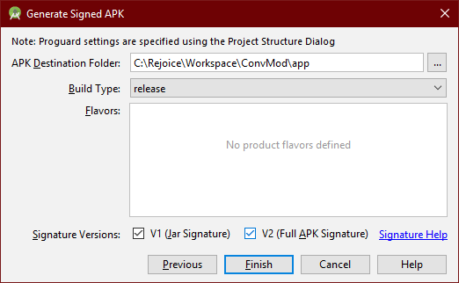

# Deploying APK in Google Play store

Use the following URL to login into Google Play store. If you have not setup an account, you need to setup a Google PlayStore account.

<https://play.google.com/apps/publish>

Click on the Create Application button for deploying new application in Google Play store.

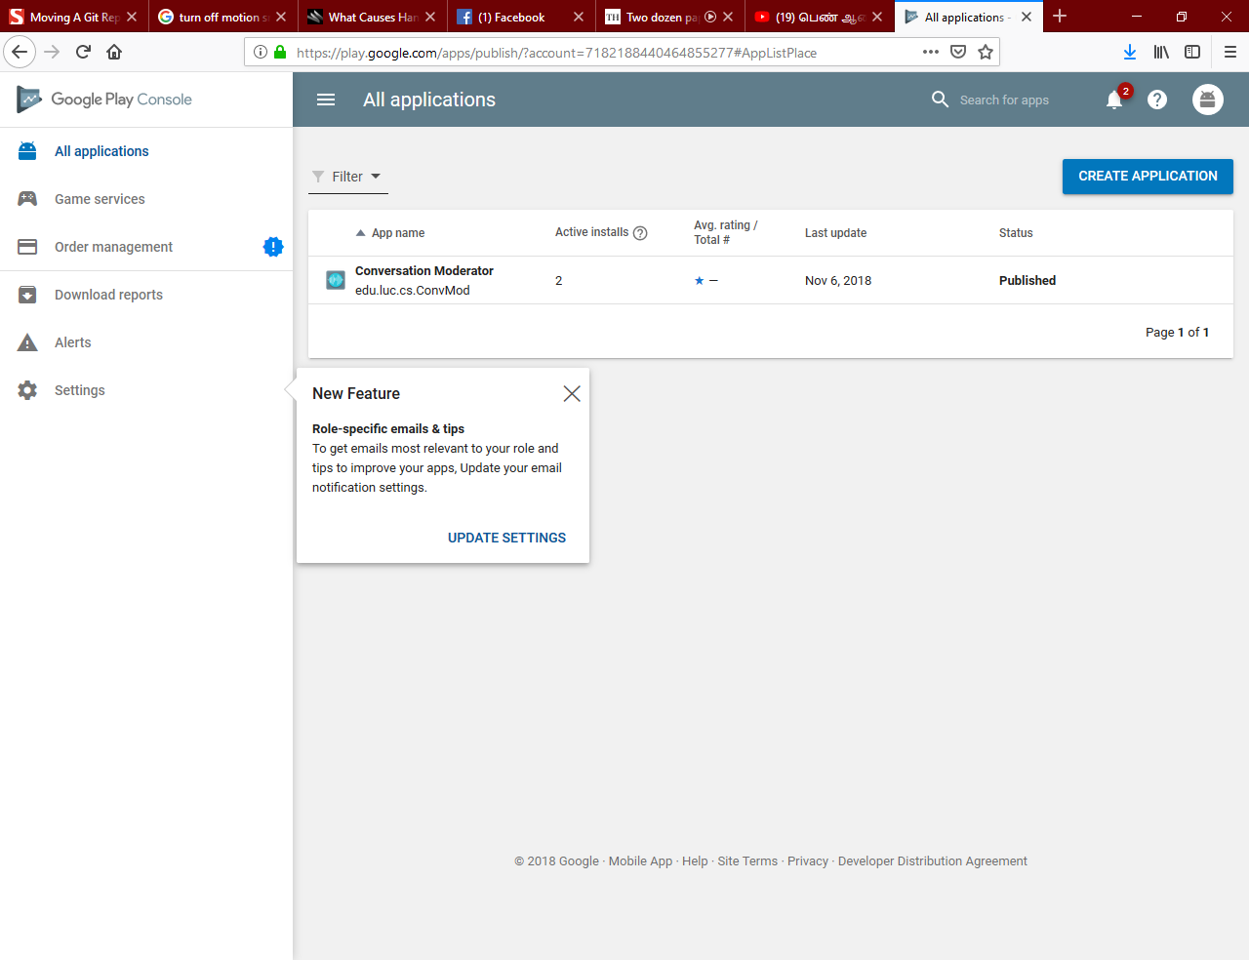

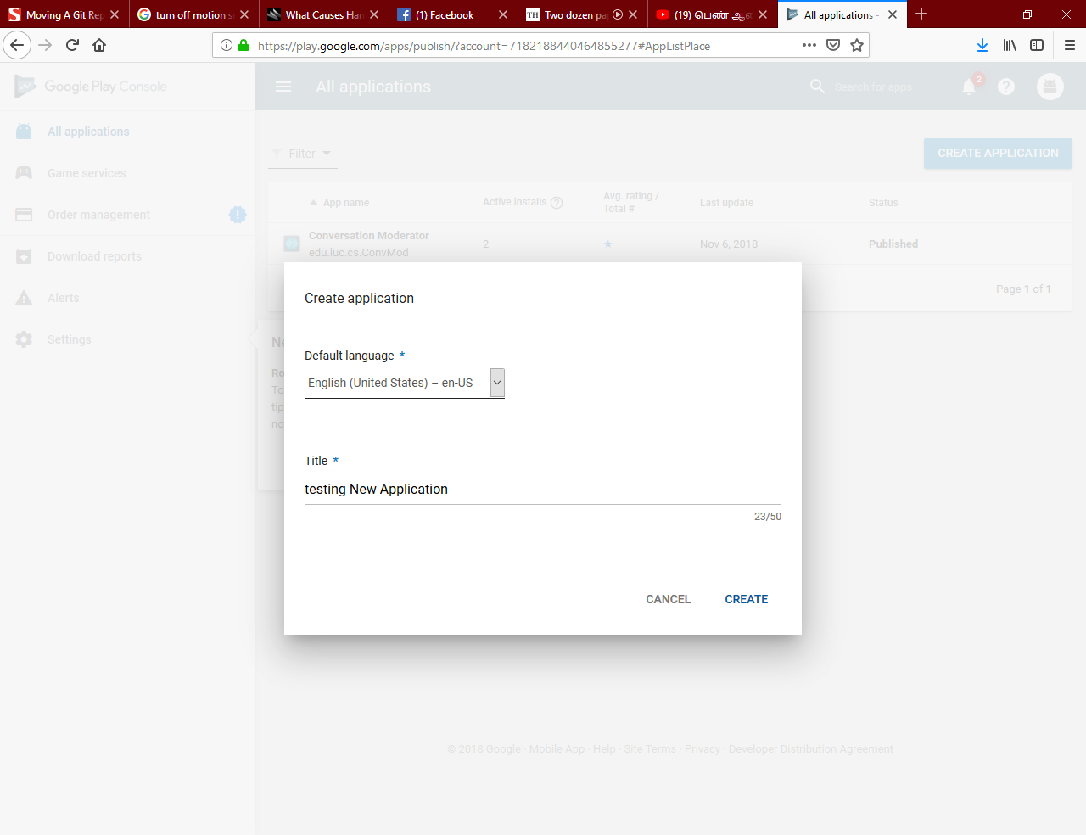

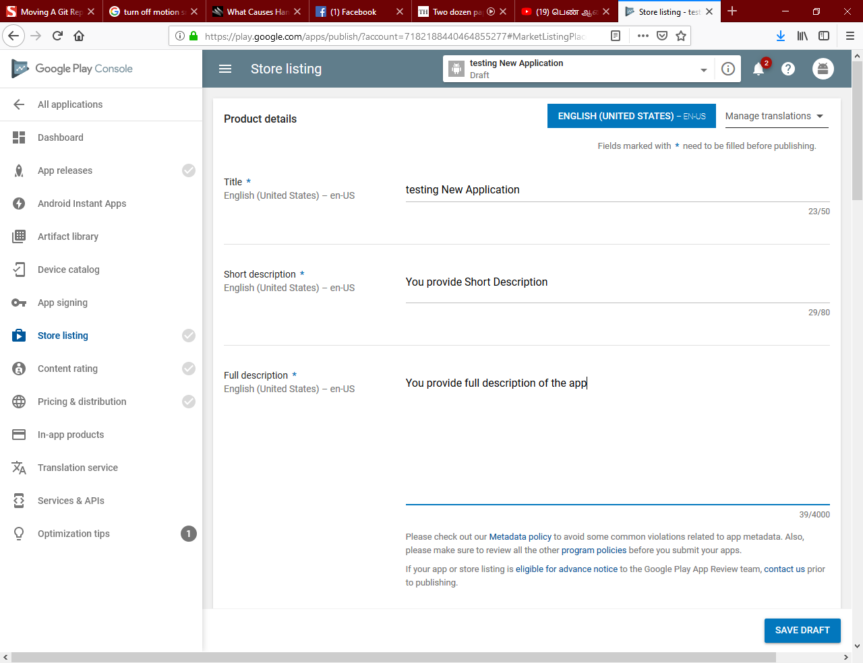

Upload screenshots of the app, which displays to App Users when they are searching / downloading the app from Google Play store.

The important files are Hi-Res Icon and Feature Graphic. For accessing the app by users, the Hi-Res Icon gets downloaded to all User phones. The icon must be of high clarity and of size 512 * 512. In addition, the Feature Graphic is the app banner that is displayed the app page.

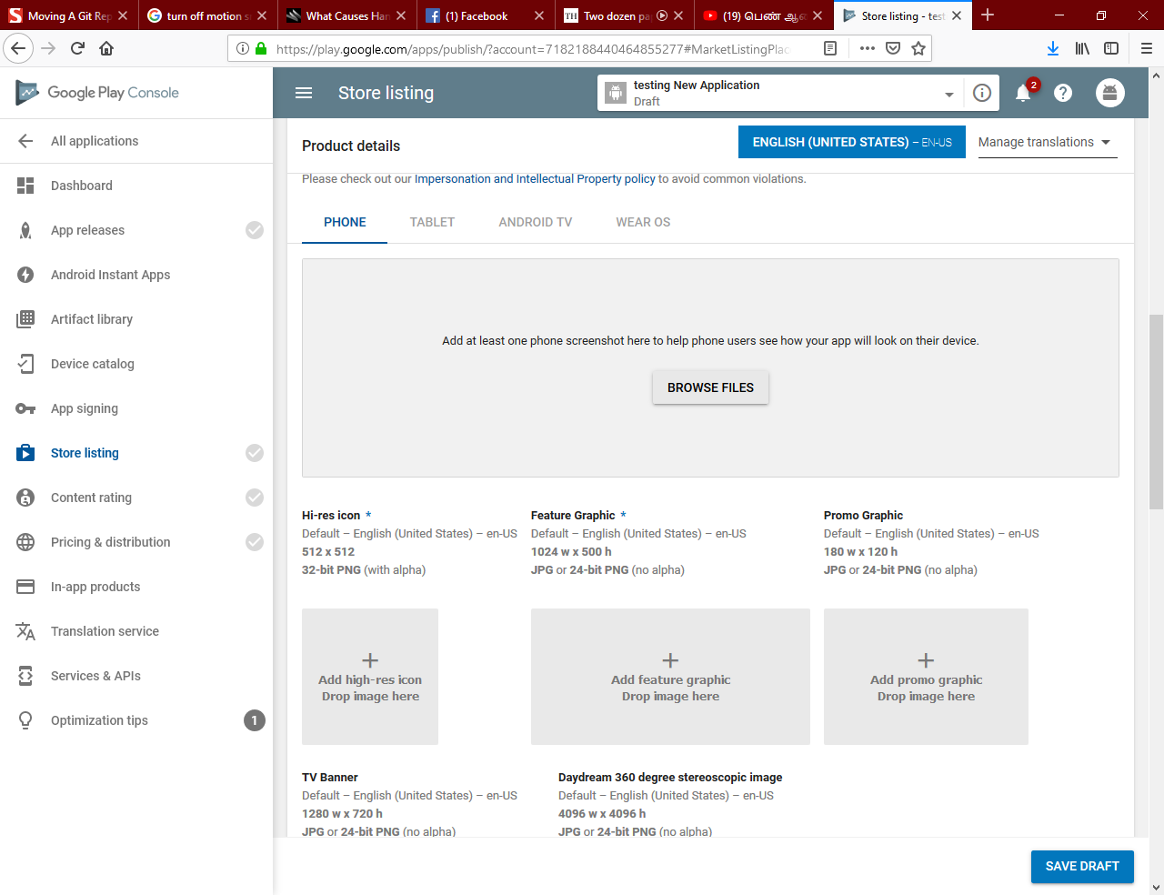

In categorization, you need to select if the app is the Application type or the Game type. Based on your selection, further category is populated.

In addition to selecting the Category, you need to fill the following questionnaire to get the content rating.

You need to provide your app Website URL and Privacy Policy.

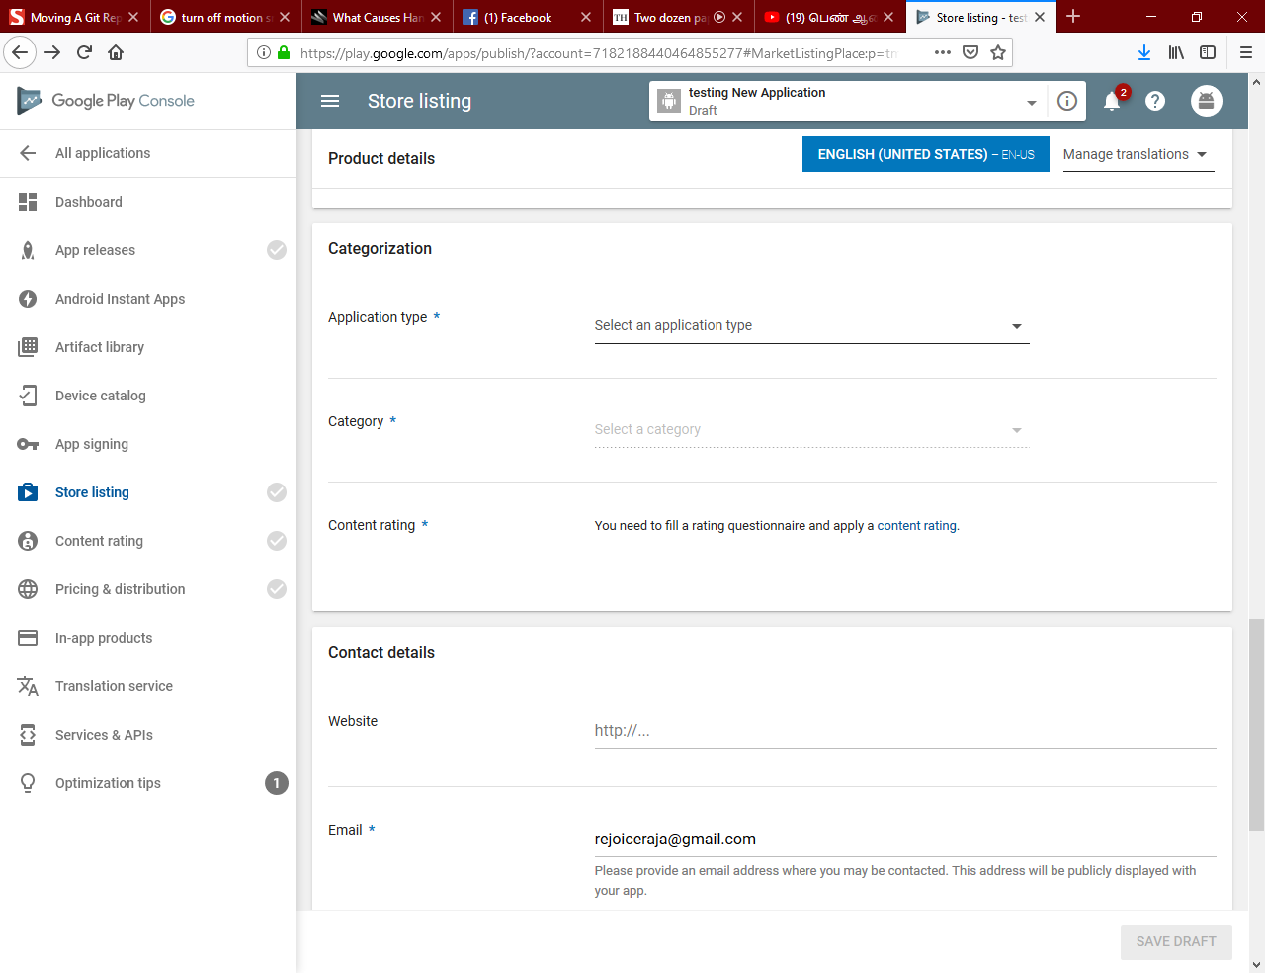

### App Releases

You release App in Google play store in different stages as Internal Testing, Alpha, Beta and Production. For internal testing, you upload the APK into Google Play store and assign testers for testing.

In subsequent Releases, you can move the existing APK to the next stage or you can upload new APK to the next stage for testing.

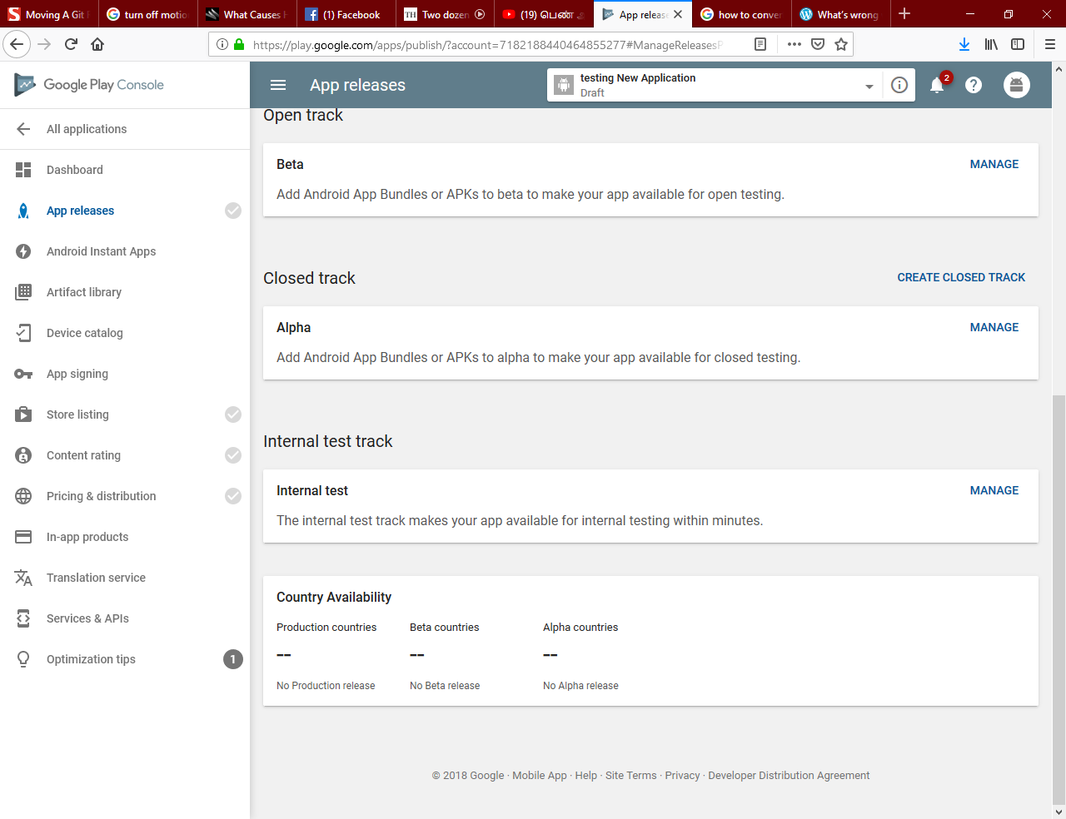

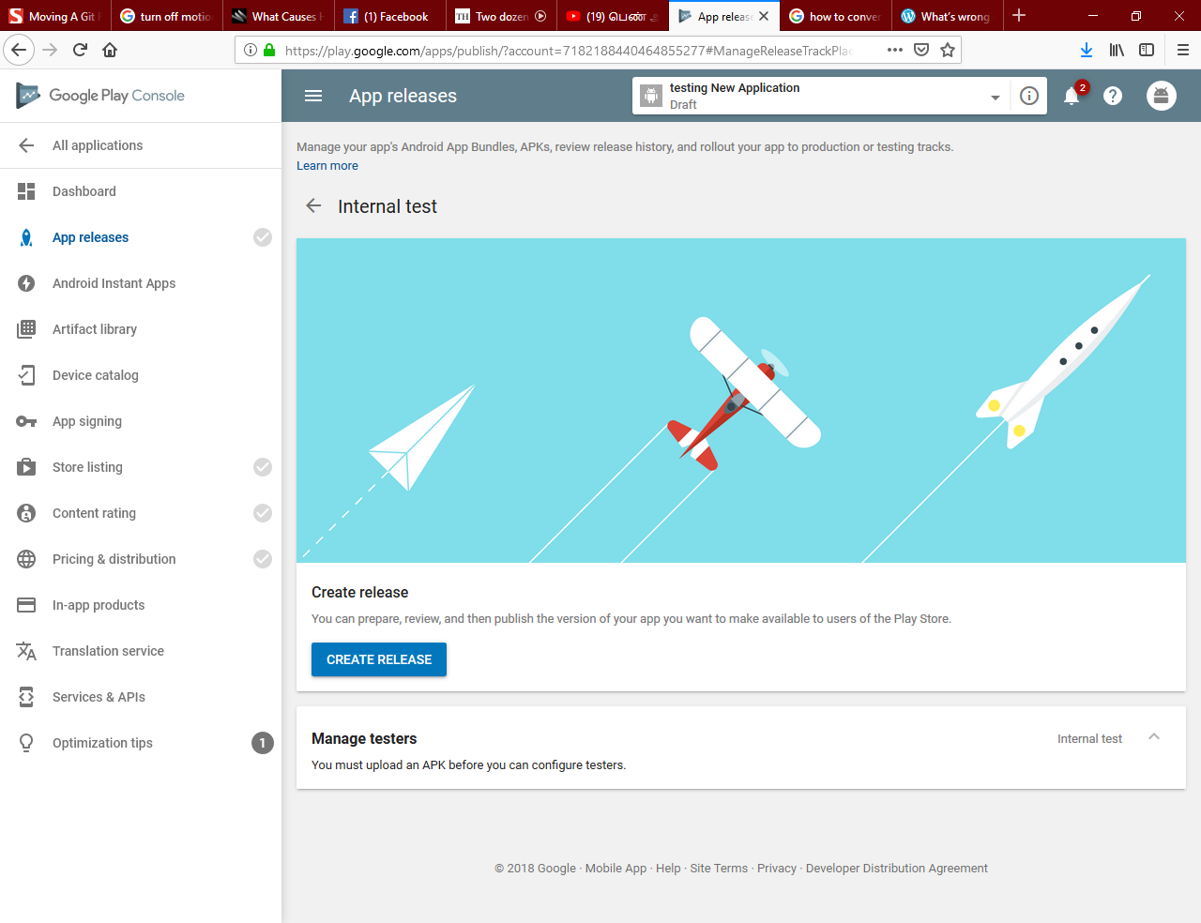

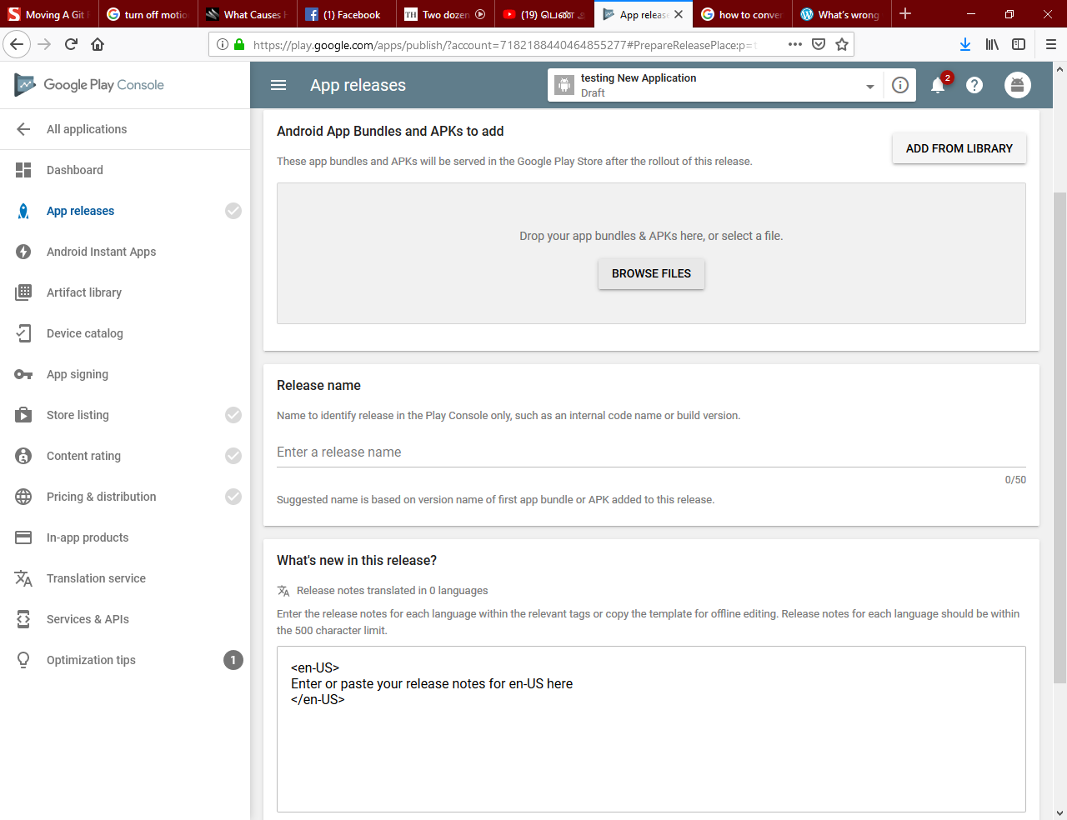

On clicking the Review / Roll out button, you can upload the APK into Google Play store. After uploading the APK, you can manage testers by uploading their Gmail email address.

Each testing will receive a unique URL through which they can download the app into their device for testing.